An

Industrial Training Report

on

**FULL STACK WEB DEVEVELOPMENT USING**

**MERN**

At

**Learn And Build**

*Submitted in partial fulfilment of the requirements for the award of the degree of*

**Bachelor of Technology**

In

# Information Technology



**(Session 2023-2024)**

**Submitted to - Submitted by-**

Ms. Maina Changeriwal Avinash Kumar

Ms. Priya Shekhawat PCE21IT013

(Faculty Coordinators- Industrial Training Seminar)

**DEPARTMENT OF INFORMATION TECHNOLOGY**

**POORNIMA COLLEGE OF ENGINEERING, JAIPUR**

**RAJASTHAN TECHNICAL UNIVERSITY, KOTA**

**August, 2023**

1

# DECLARATION

I hereby declare that the work which is being presented in the **Industrial Training** report titled **Full Stack** **Web Development using MERN** in partial fulfilment for the award of the Degree of **Bachelor of Technology** in **Information Technology** and submitted to the Department of **Information Technology**, **Poornima College of Engineering, Jaipur**, is an authentic record of my own work carried out at **Learn and Build** during the session 2023-24 (Odd Semester).

I have not submitted the matter presented in this report anywhere for the award of any other Degree.

Signature of the Student with Name & Reg. No.:

Place: ________

Date: _________

Enclosed: Training Certificate from Company

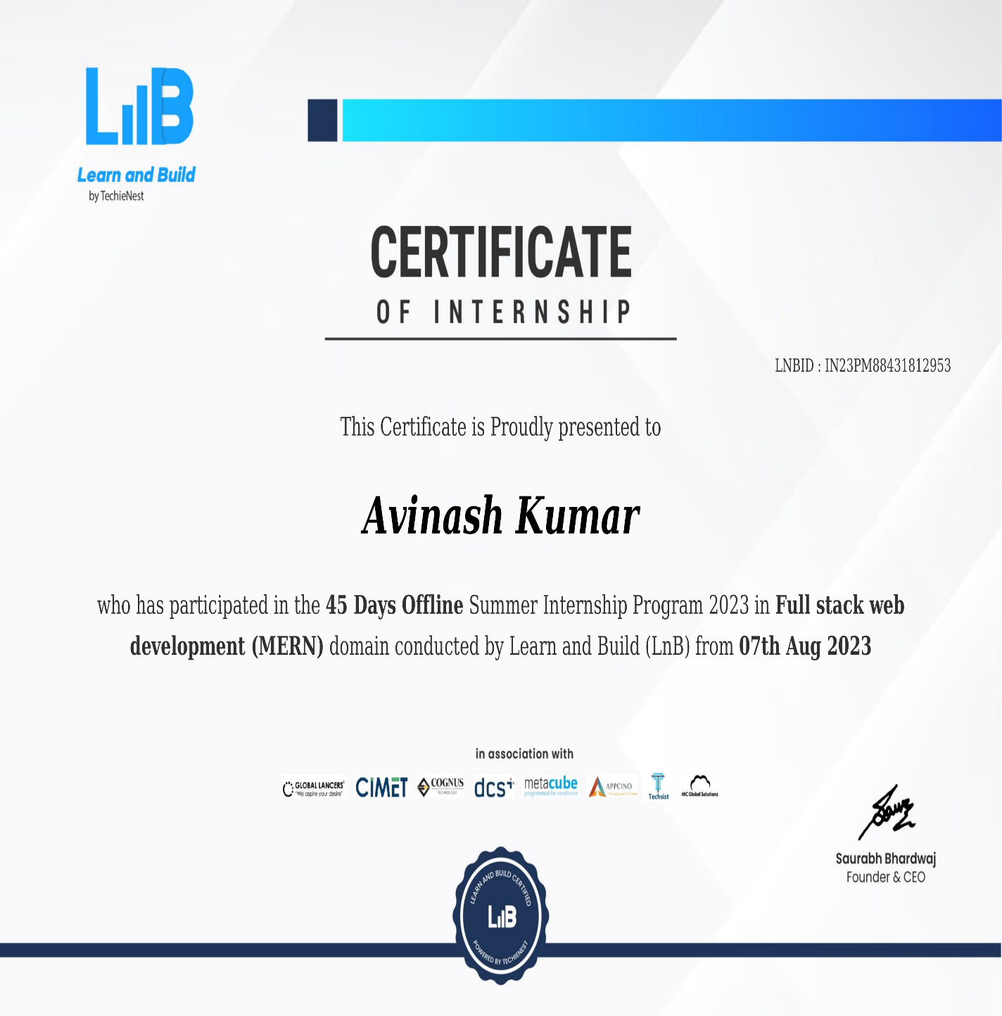



**DEPARTMENT OF INFORMATION TECHNOLOGY**

Date:7-8-2023

**CERTIFICATE**

This is to certify that **Industrial Training** report titled **Full Stack** **Web Development using MERN has** been submitted by **Avinash Kumar (PCE21IT013)**in partial fulfilment for the award of the Degree of **Bachelor of Technology** in **Information Technology** during the session 2023-24, Even Semester. The industrial training work is found satisfactory and approved for submission.

|  |  |
| --- | --- |
| **Names & Signatures** | **(Dr. Gajendra Singh Rajawat)** |
| **1. Ms. Maina Changeriwal** | HOD, IT |

**2. Ms. Priya Shekhawat**

(Faculty Coordinators- Industrial Training Seminar)

Date: ________

Place: Jaipur

# ACKNOWLEDGEMENT

The success and final outcome of learning web development required a lot of guidance and assistance from many people and I am extremely privileged to have got this all along the completion of my course and few of the projects. All that have done is only due to such supervision and assistance and I would not forget to thank them.

I respect and thank **Learn and Build**, for providing me an opportunity to do the course and project work and giving me all support and guidance, which made me complete the course duly. I am extremely thankful to the course advisor **Mr. Saurabh Bhardwaj.**

I am thankful to and fortunate enough to get constant encouragement, support and guidance from all Teaching staff which helped us in successfully completing my course.

…….……………………..

(Signature of Student)

Name of Student: - Avinash Kumar

Registration No: - PCE21IT013

Date………….

# 

## TABLE OF CONTENTS

|  |  |  |
| --- | --- | --- |
| **CHAPTER**  **NO.** | **PARTICULARS** | **PAGE NO.** |
|  | Title Page | 1 |
|  | Candidate’s Declaration | 2 |
|  | Certificate (s) of all Trainings undergone | 3 |
|  | Certificate by the Department | 4 |
|  | Acknowledgment | 5 |
|  | Table of Contents | 6-7 |
|  | List of Tables | 8 |
|  | List of Figures | 9 |
|  | Abstract | 10 |
|  | Training Platforms and Trainer description | 11 |
| 1 | Full Stack Web development  1.1 Introduction  1.2 Several aspects of web development 1.3 Process | 12  12 13 |
| 2 | Hardware and software requirement  1.1 Hardware required  1.2 Software required | 14 |
| 3 | Tools  3.1 Introduction | 15-16 |
| 4 | Technology Learned  4.1 Mongo DB  4.2 Express JS  4.3 Node JS  4.4 React JS | 17  18  19  20 |
| 5 | Projects |  |
|  | 5.1 Description  5.2 Key Features  5.3 Screenshots | 21  21-22  22-23 |
| 6 | 6.1 Conclusion  6.2 Future Scope | 23  24 |
| 10 | References | 25 |

## LIST OF TABLES

|  |  |  |
| --- | --- | --- |
| **TABLE NO.** | **TITLE** | **PAGE NO.** |
| 1 | Hardware required | 14 |
| 2 | Software required | 14 |

## LIST OF FIGURES

|  |  |  |
| --- | --- | --- |
| **FIGURE NO.** | **TITLE** | **PAGE NO.** |
| 1 | Learn And Build | 11 |
| 2 | Web Developing Process | 13 |
| 3 | Mongo DB | 17 |
| 4 | Express JS | 18 |
| 5 | Node JS | 19 |
| 6 | React JS | 20 |
| 7 | Sign up | 22 |
| 8 | Reset Password | 23 |
| 9 | Home Page | 23 |
| 10 | Check Out Page | 24 |

# Abstract

Web development is the work involved in developing a website for the Internet (World Wide Web) or an intranet (a private network). Web development can range from developing a simple single static page of plain text to complex web applications, electronic businesses, and social network services. A more comprehensive list of tasks to which Web development commonly refers, may include Web engineering, Web design, Web content development, client liaison, client-side/server-side scripting, Web server and network security configuration, and ecommerce development.

Among Web professionals, "Web development" usually refers to the main non-design aspects of building Web sites: writing markup and coding. Web development may use content management systems (CMS) to make content changes easier and available with basic technical skills.

For larger organizations and businesses, Web development teams can consist of hundreds of people (Web developers) and follow standard methods like Agile methodologies while developing Web sites. Smaller organizations may only require a single permanent or contracting developer, or secondary assignment to related job positions such as a graphic designer or information systems technician. Web development may be a collaborative effort between departments rather than the domain of a designated department. There are three kinds of Web developer specialization: front-end developer, back-end developer, and full-stack developer. Front-end developers are responsible for behaviour and visuals that run in the user browser, while back-end developers deal with the servers. Since the commercialization of the Web with Tim Berners-Lee developing the World Wide Web at CERN, the industry has boomed and has become one of the most used technologies ever.

# Training Platform

Learn and Build (LnB), an AI-enabled e-learning platform by TechieNest Pvt. Ltd. Furthering our 10+ years of strong legacy and training over 200K candidates from 300+ institutes, LnB aims at making high-quality technical education accessible to learners across the country. LnB works as the cornerstone for budding technocrats and a stepping stone for working professionals, enabling India with technology creators. It offers the independence of learning by focusing on the core aspects of niche industry-demanded skills for the positions of Embedded Engineer, IoT Engineer, Data Scientist, Data Engineer, Data Analyst, AI/ML Engineer, Security Analyst, Systems Design Architect, Cloud Engineer, DevOps Engineer, Full Stack Developer, and many other.

* **Legal Name:** TechieNest Private Limited
* **Headquarters:** Jaipur, Rajasthan, India
* **Business Model:** B2C Founding
* **Date:** 2016
* **No. of Employees:** 251 to 500
* **Core Team:** Saurabh Bhardwaj

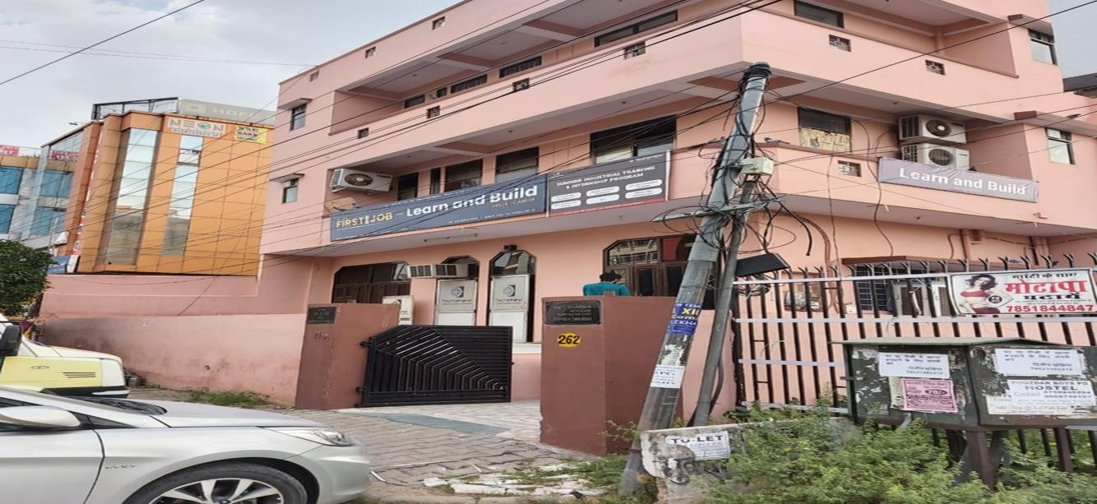

Fig 1: Learn and Build

# Trainer description

➢ Name – Mr. Bhanu Chaudhari➢ Work at TechieNest Pvt. Ltd.

# CHAPTER-1

# FULL STACK WEB DEVELOPMENT

## 1.Introduction

Web development is the work involved in developing a website for the Internet (World Wide Web) or an intranet (a private network). Web development can range from developing a simple single static page of plain text to complex web applications, electronic businesses, and social network services. A more comprehensive list of tasks to which Web development commonly refers, may include Web engineering, Web design, Web content development, client liaison, client-side/server-side scripting, Web server and network security configuration, and e-commerce development.

Among Web professionals, "Web development" usually refers to the main non-design aspects of building Web sites: writing markup and coding. Web development may use content management systems (CMS) to make content changes easier and available with basic technical skills.

For larger organizations and businesses, Web development teams can consist of hundreds of people (Web developers) and follow standard methods like Agile methodologies while developing Web sites. Smaller organizations may only require a single permanent or contracting developer, or secondary assignment to related job positions such as a graphic designer or information systems technician. Web development may be a collaborative effort between departments rather than the domain of a designated department. There are three kinds of Web developer specialization: front-end developer, back-end developer, and full-stack developer. Front-end developers are responsible for behaviour and visuals that run in the user browser, while back-end developers deal with the servers. Since the commercialization of the Web with Tim Berners-Lee developing the World Wide Web at CERN, the industry has boomed and has become one of the most used technologies ever.

## 1.2 Several Aspects of Web Development

* Navigation
* Positioning and alignment
* Colour
* Mobile friendly
* Typography
* Usability

**1.3 Process:**

These are the steps considered while developing a webpage:

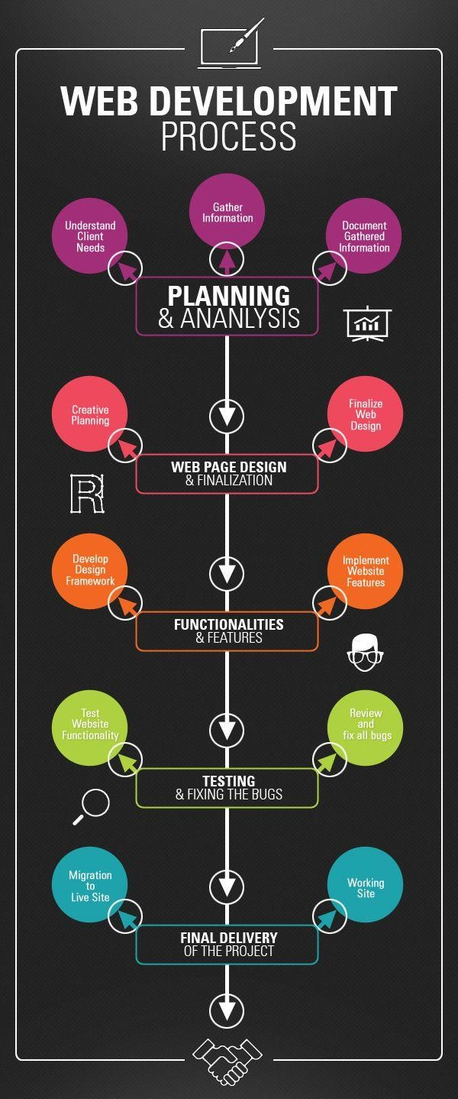

**Fig 2-Web Developing Process**

**CHAPTER-2**

# HARDWARE AND SOFTWARE REQUIREMENT

**2.1 Hardware Required:**

TABLE 1-HARDWARES REQUIRED

|  |  |  |
| --- | --- | --- |
|  | **Number** | **Description** |
| 1. |  | Pentium 4, Window XP/Window 7 |
| 2. |  | 256 MB RAM |

**2.2 Software Required:**

TABLE 2-SOFTWARES REQUIRED

|  |  |
| --- | --- |
| **Number** | **Description** |
| 1. | Windows XP,7 |
| 2. | Mongo DB |
| 3. | IIS server |
| 4. | HTML/CSS/JavaScript/ReactJS/Express JS/Node JS |

# CHAPTER 3

# TOOLS

## 3.1 Introduction

1. **Text Editor or Integrated Development Environment (IDE):** 
   * **Visual Studio Code (VS Code):** A popular, open-source code editor with extensive support for JavaScript, React, and Node.js. It offers numerous extensions and a rich ecosystem of plugins to enhance your development workflow.
2. **Version Control System (VCS):** 
   * **Git:** A distributed version control system that helps you track changes in your codebase. Platforms like GitHub, GitLab, or Bitbucket are commonly used for hosting Git repositories and collaborating with others.
3. **Package Manager:** 
   * **npm (Node Package Manager):** npm is the default package manager for Node.js. It allows you to install and manage third-party libraries (packages) and modules needed for your MERN project.
4. **Terminal/Command Line Interface (CLI):** 
   * **Terminal (macOS/Linux) or Command Prompt (Windows):** These built-in command line interfaces are used for running various commands, starting development servers, and managing project dependencies.
5. **Database GUI (Graphical User Interface) Tools:** 
   * **MongoDB Compass:** A graphical user interface for MongoDB that allows you to interact with your MongoDB databases visually, making it easier to create, view, and manipulate data.
6. **API Testing Tools:** 
   * **Postman:** A popular tool for testing APIs. You can use it to send HTTP requests to your Express.js server and receive responses, helping you ensure your API endpoints work as expected.
7. **Browser Developer Tools:** 
   * **Chrome DevTools:** A set of web developer tools built into the Google Chrome browser. It's invaluable for debugging and inspecting web applications built with React and JavaScript.

1. **Front-end-Development-Tools:** 
   * **React Developer Tools:** A browser extension for Chrome and Firefox that enhances the debugging experience for React applications, allowing you to inspect React components and their state.
2. **Server-side Tools**:

➢ **Express.js Generator:** While not necessary, you can use the Express.js Generator to scaffold the initial structure of your Express.js application, making it easier to start your server-side development.

1. **REST Client (optional):**

➢ **REST clients like Insomnia or Paw:** These tools are helpful for testing and debugging RESTful API endpoints during development.

1. **Online Code Repositories:**

➢ GitHub is a valuable resource for finding open-source MERN projects and code samples to study

**CHAPTER 4**

**TECHNOLOGY LEARNED**

## 4.1 Introduction: -

The **MERN** stack is a popular technology stack for building modern web applications. It consists of four main components: **MongoDB, Express.js, React, and Node.js.**

**4.2** **MongoDB (Database):**

* **Type:** NoSQL (Document-oriented) database.
* **Storage:** Stores data in BSON (Binary JSON) format.
* **Scalability:** Designed for horizontal scalability, making it suitable for large-scale applications.
* **Query Language:** Uses a query language similar to JSON for data retrieval.
* **Consistency:** Offers tunable consistency levels for read and write operations.
* **Community Edition:** Open-source version available for free.

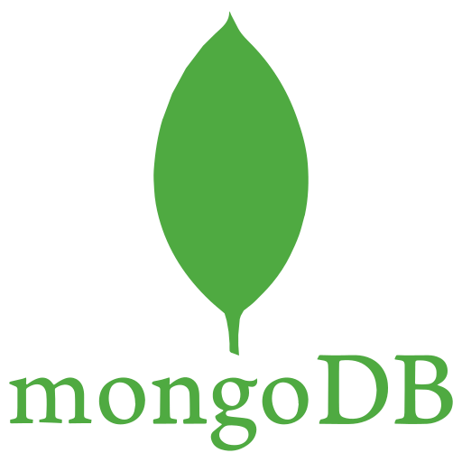

**Fig 3: MongoDB**

**4.3 Express.js (Server-side Framework):**

* **Type:** Minimal and flexible Node.js web application framework.
* **Middleware:** Supports middleware to handle HTTP requests and responses.
* **Routing**: Provides a robust routing system for defining API endpoints.
* **Templating:** Supports various template engines like EJS, Pug, and Handlebars.
* **Performance:** Known for its fast and efficient performance.
* **Type:** JavaScript library for building user interfaces (UI).
* **Component-Based:** Organizes UI into reusable components.
* **Virtual DOM:** Employs a virtual representation of the DOM for efficient rendering updates.
* **Declarative:** Describes how the UI should look based on the application's state.
* **React Native:** Extends React for building mobile applications.



**Fig 4: Express JS**

**4.4 Node.js (Runtime Environment):**

* **Type:** JavaScript runtime built on Chrome's V8 JavaScript engine.
* **Asynchronous:** Utilizes non-blocking, event-driven architecture.
* **Server-side:** Used for server-side scripting and building scalable network applications.
* **Package Manager:** NPM (Node Package Manager) for managing third-party libraries and modules.
* **Community:** Has a vast and active open-source community.
* **Cross-Platform:** Runs on various operating systems (Windows, macOS, Linux). The MERN stack's technology specifications make it a powerful choice for developing fullstack web applications. MongoDB offers flexible and scalable data storage, Express.js simplifies server- side logic, react provides a dynamic and efficient front-end framework, and Node.js enables server-side scripting and real-time applications. Combining these technologies allows developers to build modern, responsive, and scalable web applications.

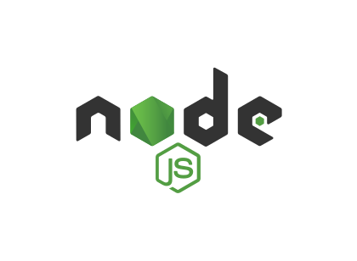

**Fig 5: Node JS**

**4.5 React JS (Front End Framework):**

* **Component-Based Architecture:** React is centred around the concept of reusable components. Components are self-contained, independent units that encapsulate the UI and behaviour of a part of the user interface.
* **Virtual DOM:** React uses a Virtual DOM (Document Object Model) to efficiently update the user interface.
* **Unidirectional Data Flow:** React follows a unidirectional data flow, also known as the "props down, events up" pattern. Data is passed from parent components to child components via props, and child components can communicate with their parent components by emitting events.
* **JSX (JavaScript XML):** React allows you to write UI components using JSX, a syntax extension for JavaScript. JSX looks similar to HTML but is actually a way to describe the structure and appearance of UI elements within JavaScript code. JSX is transpiled into standard JavaScript before it's executed in the browser.
* **React Ecosystem:** React has a thriving ecosystem with a wide range of libraries and tools that complement its core functionality.

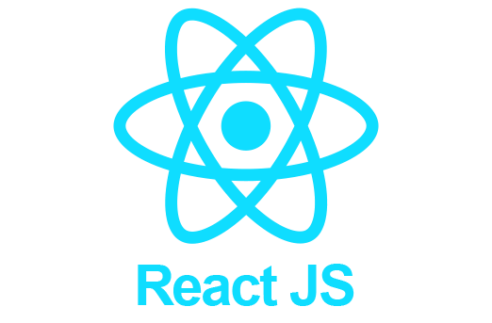

**Fig 6: React JS**

# CHAPTER-5

# Projects

**5.1 Description:**

**Shoppi** is not just **an e-commerce website**, it's your one-stop destination for all your online shopping needs. With a name that reflects simplicity and convenience, Shoppi is designed to provide an unparalleled shopping experience that is as enjoyable as it is efficient.

At **Shoppi**, we understand the fast-paced nature of modern life, and that's why we've curated a vast selection of products from top brands and sellers across various categories. Whether you're looking for fashion, electronics, home essentials, beauty products, or unique gifts, Shoppi has it all.

**5.2 Key Features of Shoppi:**

* **Extensive Product Range:** Shoppi offers a wide range of products, ensuring that you can find everything you need in one place.
* **User-Friendly Interface:** Our website's intuitive design makes it easy for you to browse, search, and discover products effortlessly.
* **Secure Shopping:** We prioritize the security of your personal information and transactions. Shop with confidence, knowing your data is safe.
* **Customer Reviews and Ratings:** Make informed purchasing decisions by reading reviews and ratings from other shoppers.
* **Seamless Checkout:** Our streamlined checkout process ensures a hassle-free shopping experience.
* **Fast Shipping:** We offer quick and reliable shipping options to get your purchases to your doorstep as soon as possible.
* **Responsive Customer Support:** Have questions or concerns? Our dedicated customer support team is ready to assist you.
* **Exclusive Deals and Discounts:** Shoppi regularly features special promotions and discounts to help you save on your favorite products.
* **Mobile-Friendly:** Enjoy shopping on the go with our mobile-responsive website or mobile app.
* **Community and Social Integration:** Connect with fellow shoppers and share your finds on our social media channels and community forums.

**5.3 SCREENSHOT OF PROJECT:**

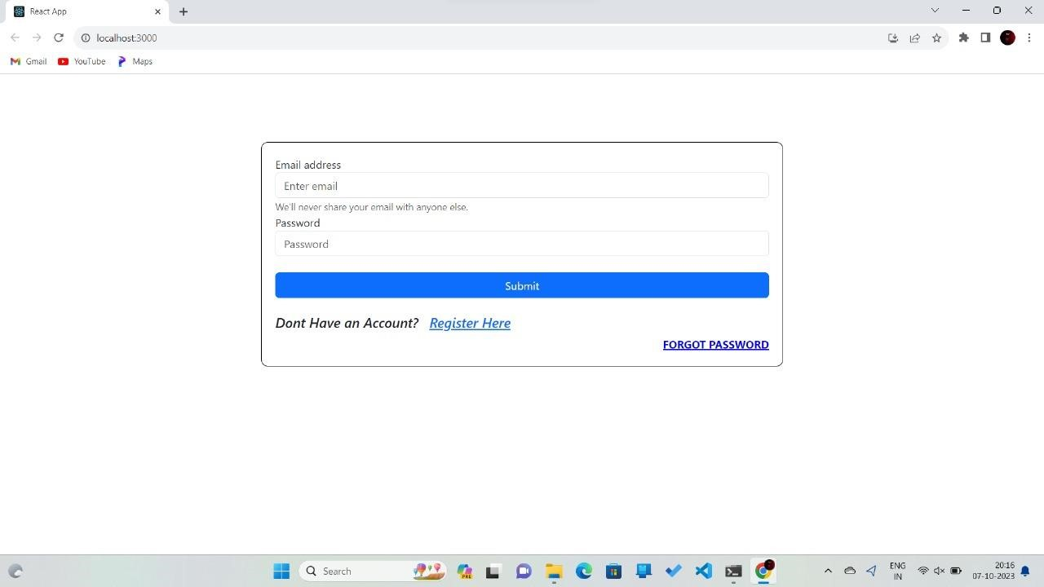

**Fig 8 : Sign up**

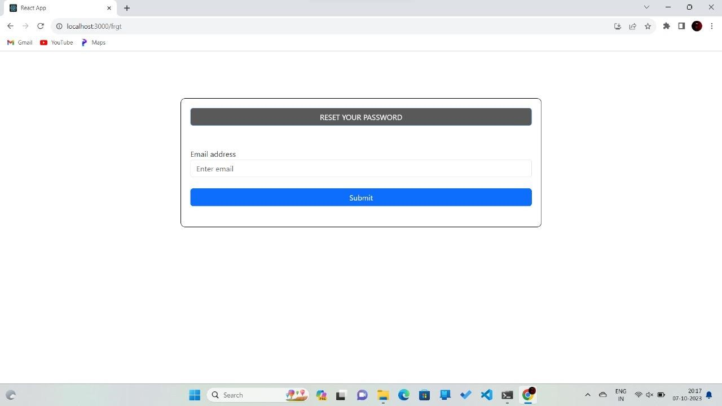

**Fig 7: Reset password**

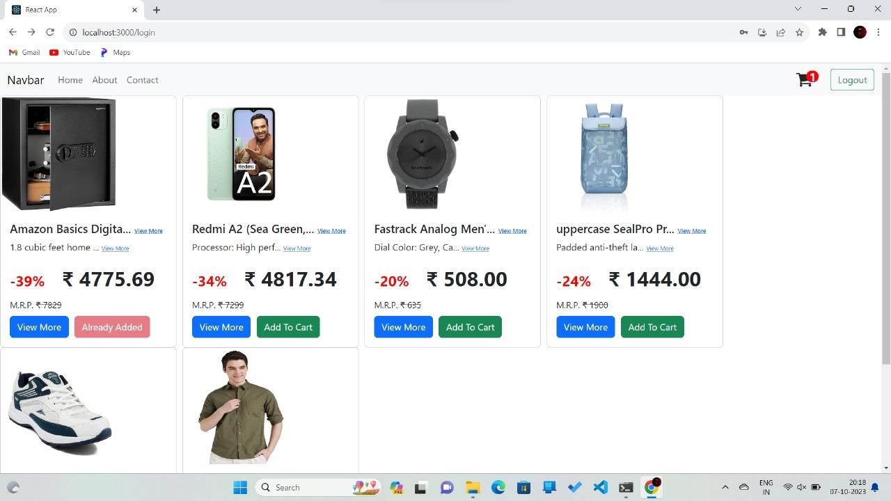

**Fig 9: Home Page**

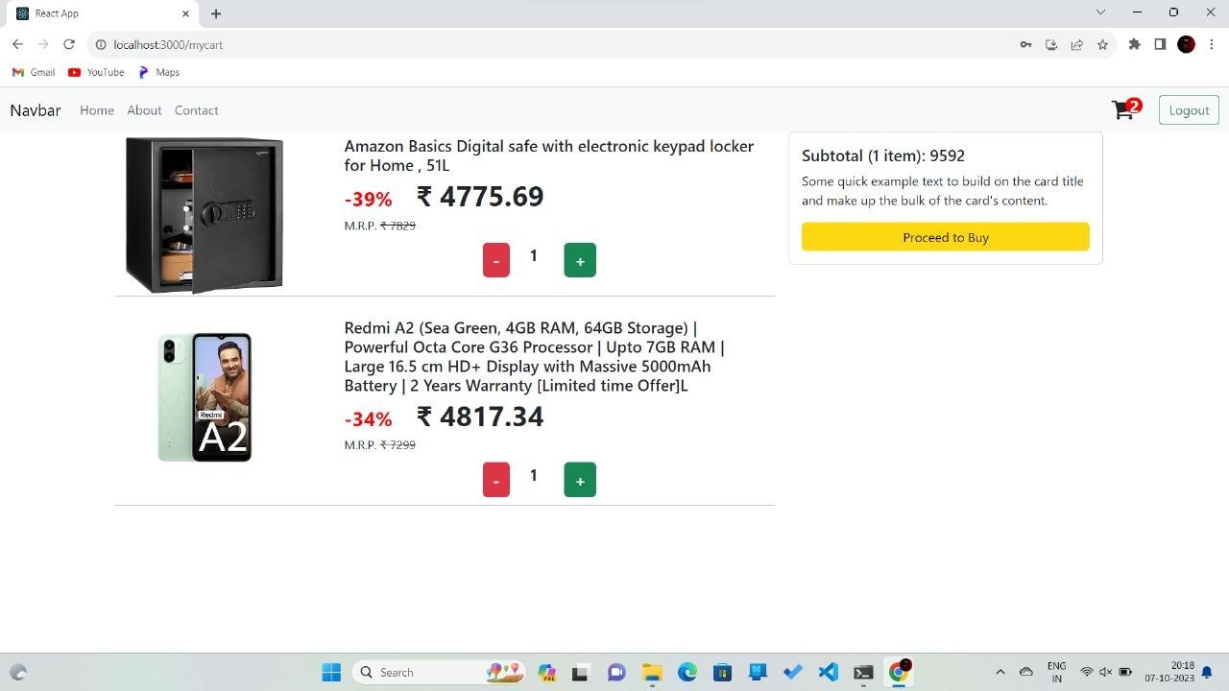

**Fig 10: Check Out Page**

# CHAPTER: 6

# CONCLUSION AND FUTURE SCOPE

**6.1 CONCLUSION:**

In conclusion, my journey into the world of the MERN stack has been both enlightening and empowering. Through the exploration of MongoDB, Express.js, React.js, and Node.js, I have acquired a comprehensive skill set that has redefined my capabilities as a web developer.

This learning journey has underscored the significance of full-stack proficiency, allowing me to seamlessly navigate between front-end and back-end development, thereby enhancing my adaptability and marketability in the rapidly evolving tech industry.

The modularity and reusability principles ingrained in React have revolutionized my approach to creating user interfaces, promoting not only efficiency but also code elegance and maintainability. In MongoDB, I've found a reliable companion for managing data, unlocking insights into the world of non-relational databases.

Node.js and Express.js have empowered me to construct robust server-side applications, fostering a deeper comprehension of server operations and API development. Additionally, my exposure to various development tools and libraries has streamlined my workflow and amplified my productivity.

As I conclude this MERN journey, I carry with me a profound appreciation for continuous learning, knowing that the tech landscape evolves perpetually. My projects and interactions with the MERN community have further enriched my experience, cementing my commitment to innovation and excellence in web development. This journey is a stepping stone towards a future brimming with possibilities, and I am excited to embark on new adventures that lie ahead.

## 6.2 FUTURE SCOPE

If someone has no experience in this field, finding work can be a real challenge. successful internship can help an individual turn an experience into a career opportunity. So as a successful internship some future scopes are:

* To work in IT company.
* Can work as a Software Engineer.
* Can work as a Web Designer.
* Can work as a Web Developer

## CHAPTER 7

## REFERENCES

* http://www.w3schools.com
* http://www.w3.org/standards/semanticweb/
* http://developer.mozilla.org/en/docs
* http://sioc-project.org/ontology
* http://janastu.org